Notes 1-23

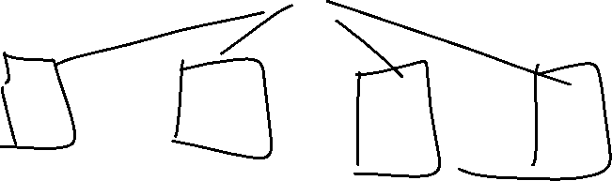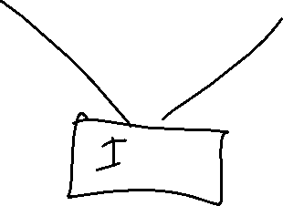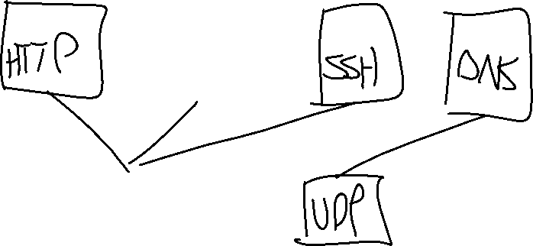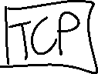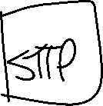

IP is important (the thing in TCP/IP)

* As many protocols above or below IP

TCP: Transmission control protocol

* Gives us reliable delivery
* Reliable byte stream
  + Reliable:
    - All delivered
    - In order
    - Error free

UDP: User datagram protocol

* Unreliable delivery
* Steam:
  + A sequence of
  + A byte stream is just a sequence of bytes
* We do not have the guarantees of delivery, in order, or error free.
* “best effort” protocol

RFC: Request for Comments

* Published standard for how things work on the internet

BST API?

* OSI is a fixed standard
* TCP is an open standard

BST: Berkely System Distribution

Socket: Where we plug into the network

* Functions:
  + Socket
  + Bind
  + Listen
  + Accept
    - We use all of these while building a server
    - Passive open

Client Connection:

* Socket
* Connect
  + Active open

More:

* Send
* Recv
* Close

Example Server:

* Memset(
  + Holding shift + k while hovering will show how to use
* We will be using specific code style in this class
  + KNF: Kernel Normal Form

Socket:

Bind:

* Sockaddr
  + Data structure